Biznado (Natalia Wocial Przemysław Adam Mączka) & Klocki (Aga Patro, Jakub Młocek)

**ANALYSIS OF CURRENT SYSTEMS, PROCESSES AND ARCHITECTURES AND PROPOSED CHANGES**

From our in-depth analysis, changes need to be made at Eklamot in the following areas:

**PSM**

It's a good practice to have Privileged Session Manager. PSM Isolates, controls, monitors and records privileged sessions in real-time. It also provides a single point of access control, prevents malware from entering, and records every keystroke and mouse with continuous monitoring. Privileged accounts provide access to critical systems and valuable enterprise data. If misused, these accounts can cause problems. To protect critical assets, organizations should adopt a zero-trust approach when it comes to activity using privileged accounts. Working in a zero-trust model requires organizations to proactively monitor and record all privileged sessions. Through this, malicious employees, inexperienced external users or hackers are unable to damage critical systems or gain unauthorized access to critical data. Organizations should also isolate privileged sessions so that malware cannot spread from a user's computer to a critical system.

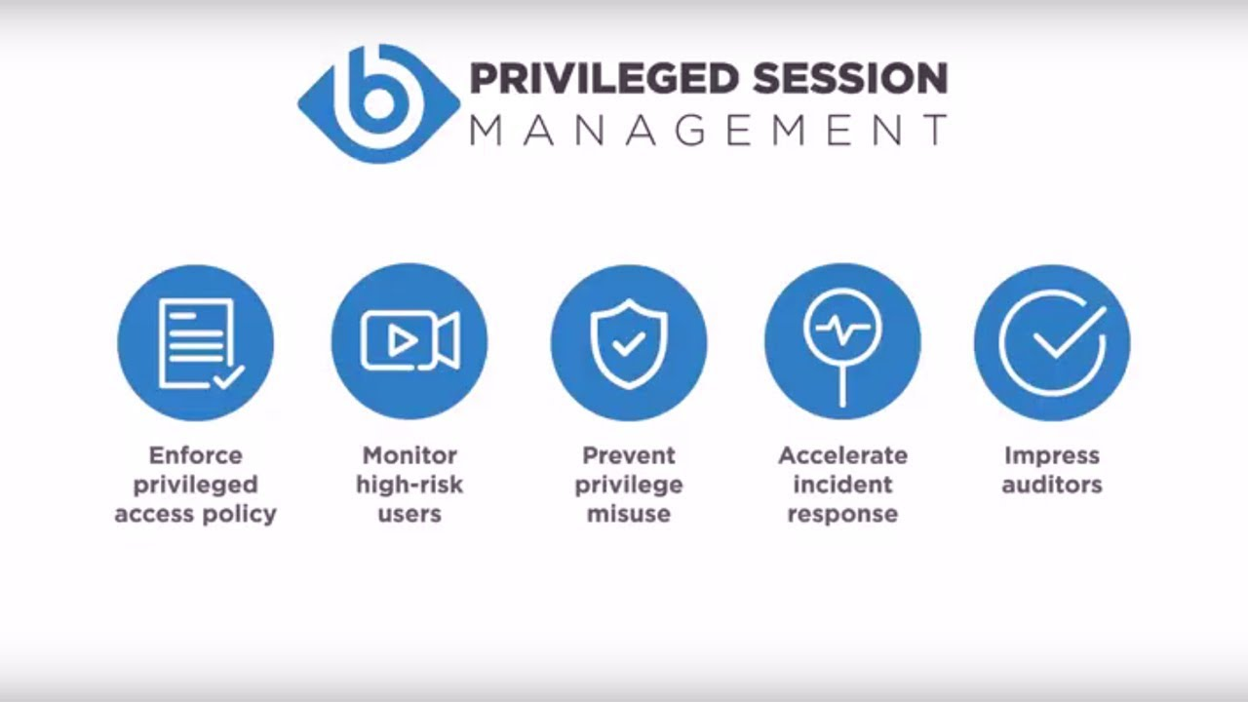

**SOC (Security Operation System)**

The SOC monitors and analyzes activity in networks, servers, endpoints, databases, applications, websites and other systems, looking for anomalies that could indicate security incidents or attempts. The SOC is responsible for ensuring that potential security incidents are correctly identified, analyzed and ultimately reported to Customers for further action.

For Eklemot we suggest SOC provided as a service by an external provider. This approach is recently quite popular, not only among small organizations, but also among large institutions due to its effectiveness and relatively low maintenance costs. SOC maintained by an external provider, MSSP (Managed Security Service Provider) guarantees access to specialized knowledge and tools tailored to the customer needs. We agree with the provider on the scope of provided tools and time needed to perform specific tasks with their help, and we settle for agreed monthly rates. If at some point there is a need to switch off or on additional services, we do it overnight without incurring additional costs. Flexibility, availability and high level of expertise are the main advantages of this solution. 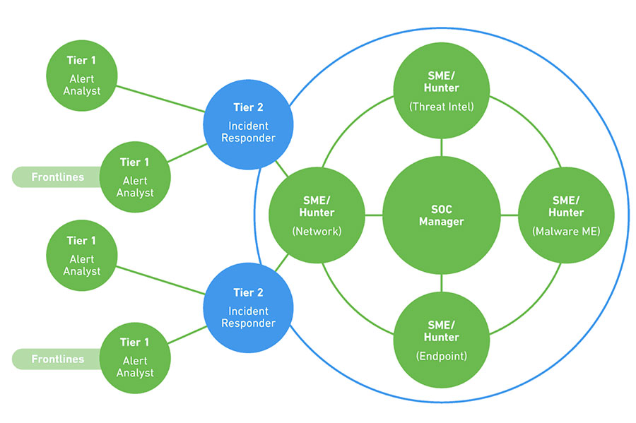

**SUDOERS**

The sudoers file is a file used by Linux and Unix system administrators to grant system permissions to system users. This allows the administrator to control the activities of other users. For security reasons, before executing a command that requires administrator privileges, Linux checks the sudoers file to see if the user name is included in the administrator’s list of permissions, preventing unauthorized persons from executing the action.

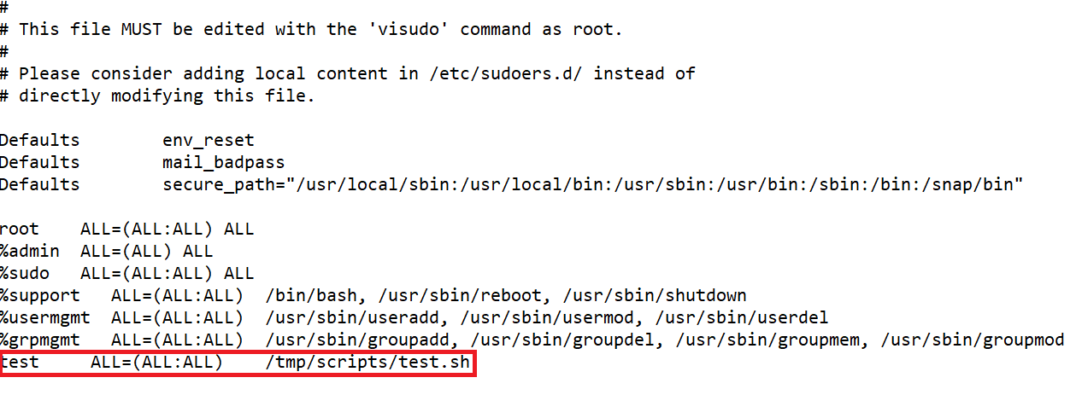

**In Eklemot company configuration line “test ALL=(ALL:ALL) /tmp/scripts/test.sh”** is potentially dangerous. User test can execute with sudo privileges **“test.sh”** script which source code can be modified. This means he can execute each command as a root which poses a potential threat to the company. Moreover group **“%support”** shouldn't have access to run/bin/bash as root. It also allows to run any available commands as root which should be more specified for support.

**NMAP**

NMAP is an open-source network mapping tool for network exploration and security audits. It is designed to scan large networks, but it also works well for individual addresses. NMAP uses low-level IP packets to identify which addresses are available on the network, which services are available, which operating systems, which firewall types are used, and dozens of other features. NMAP is commonly used for security audits, many network and system administrators use it to perform routine activities such as inventorying network resources, managing software updates, and monitoring systems and uptime.

The result of NMAP is a list of scanned addresses with additional information depending on the selected options. One of the most important pieces of information is the “List of Interesting Ports.” It contains port numbers, logs, service names, and detected status. The condition can be described as open, filtered, closed, or unfiltered.

* Open means that the application on the investigated address is waiting for incoming connections/packets on this port.
* Filtered means that a firewall system or other device blocking network traffic does not allow communication to that port and therefore NMAP cannot detect whether the port being tested is open or closed.
* The closed port does not have an application that supports network communication.
* Ports classified as unfiltered responded to NMAP queries, but it was not possible to determine whether they were open or closed.

Any open port is potential access for hackers to attack a company. Therefore, it is very important to make sure that ports that do not wait for connections/packets are closed. The following screenshot shows that Eklamot’s IT team neglected this case, and unknowingly allow criminals to launch an attack. It is very important to close ports that are currently not used.

**Ports to be opened:**

Having too many open ports expose servers to many potential attack vectors. Opened should remain only:

1. “21 (ftp)” for file transfer protocol.
2. “80 (http)” for website to be achieved.
3. “443 (https)” for secure website traffic.

**Why close some ports?:**

* We decided to close port 111. RPC service has a history of security vulnerabilities. Having this port exposed allows everybody to query information without a need to authentication. It should be opened only for certain whitelist of IPs.
* Port 3306 should also be closed. Exposing port 3306 can make our server vulnerable to attack. If a connection to database is necessary it is preffered to use ssh tunel instead.
* Ports: 4767, 4769, 5037, 39381 haven't got any known reason to be oppened. We need documentation of applications for further decisions.
* Port 39563 should be closed, webdav works on port 80 and 443 by default.
* Ports: 53013, 53014, 53113, 53114 should be closed tempolary, becouse of CVE-2021-21783 vulnerability avaliable for gSOAP 2.8.
* Moreover there is an Exploit avaliable for ftp vsftpd 2.3.4 which is used in our application. It should be updated rapidly to the newest version.

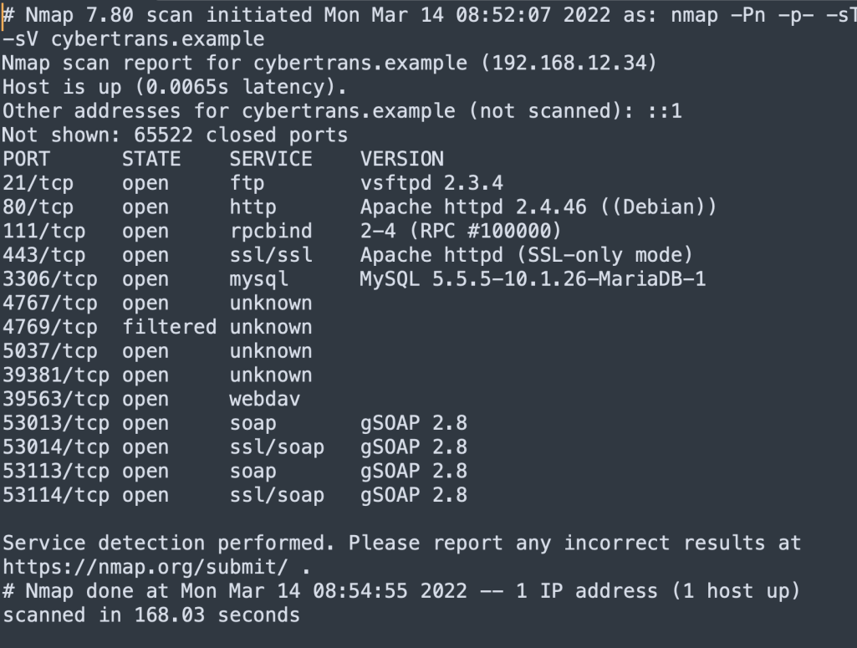

**Password Policy and Users Data**

A password policy is a set of rules designed to enhance the security of the user and the device they work on. Password policies are often part of official corporate policies and can be taught in cybersecurity training. Moreover, we would like to incorporate two more rules which would make it much more difficult for the malware or hackers to get into our accounts or systems:

* We should force changing the temporary password after the first login, not only kindly ask for it. Most of the employees just stick to the generic one which is a perfect opportunity for an easy attack.
* Adding two-factor authorization would be a great idea. Since almost everybody nowadays has a mobile device, authorization application or mobile authorization should not be much of a problem for workers of Eklamot.
* Passwords should almost always be stored as hashes of hash function (f.e. sha-256) not a plain text. Hashes are irreversible, so even if the attacker will find our database, he has to put in lots of effort to get plain text passwords.
* Security of personal data of customers is extremely important. Any potential leak can couse destructive consequences for whole company. As so database should be well protected.

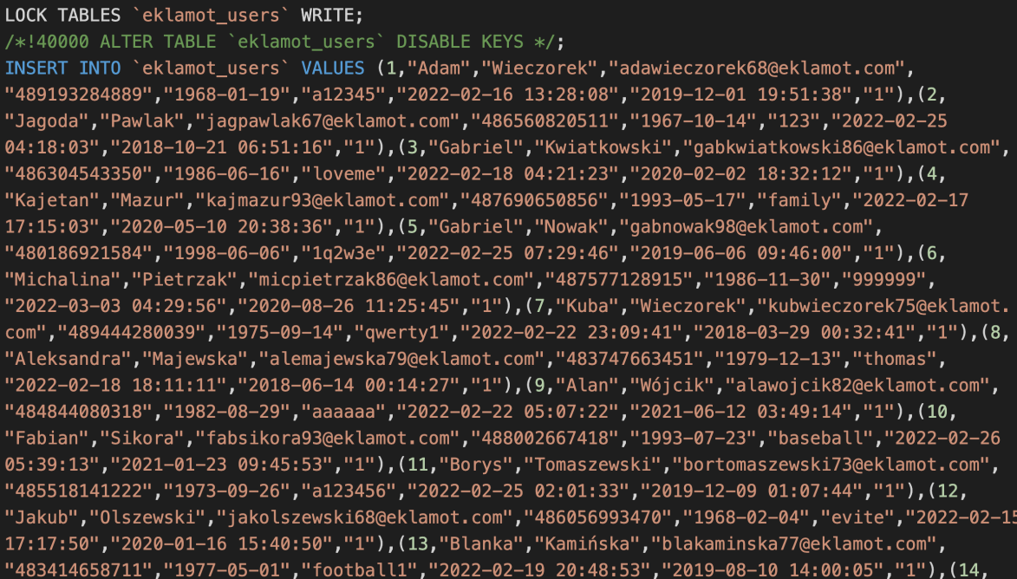

**Architecture**

In order to run the whole system without further problems, we would like to implement a few changes in the architecture of our project. Key changes would consist of:

* A backup server should be accessible only for admin employees.

Many employees have root privileges and can perform actions that can do big damage to the system. For this kind of situation, the company has a backup server. Only a few people should have access to this server in order to secure the system from accidental damage done by the employees.

* Employees should not have access directly to the restricted zone.

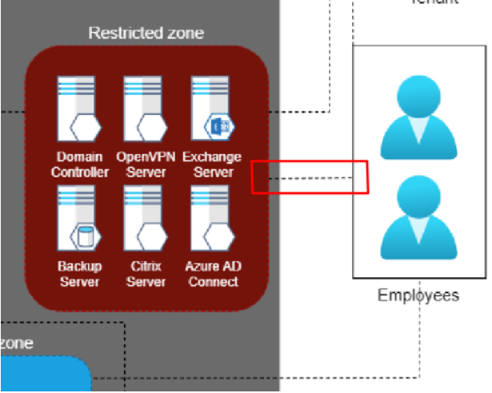

Here we have a connection between employees directly with the restricted zone, from their own computers. We cannot control what employees do or follow them. Thus we deleted this connection because now employees can access the restricted zone only from their business computer, which is followed by the company.

Also, we noticed that employees are connecting with workstations without any protections, so we add VPN Gateway which is shown by the image below.

* A new firewall between the Front-End Server and Database Server.

External FTP server is connected directly from outside of Eklamot company to Application 1. It is necessary to redirect that connection thru Firewall and DMZ zone. Each move from the outside of the company should be filtered and checked. If FTP server has any vulnerabilities attacker will be able to access directly Application 1. Company should also implement usage of sFTP instead of FTP. All files sending thought FTP are not encrypted and can be spoofed which is not possible via sFTP.

* sFTP instead of FTP and connection thought firewall and DMZ zone.



As attacks can be performed from the Front-end level (for example XSS, CSRF, or SQL injection attacks, which can be used to steal data from our database), we should protect our databases (which as we know have sensitive data!). That kind of protection can provide a firewall and for more safety, we decided to add another one, between the Front-end server and our database.

* Both Application2 should have access to database2.

Load balancer balance actions between these two applications. These applications are the same application so we think they both should be connected to VPN.

The graphical representation of how it should look like:

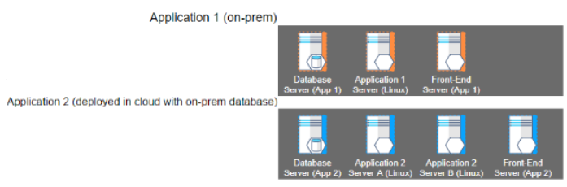

**Changes to the vulnerability administration process in Eklamot**

**Changes we suggest:**

Security scanners are not ideal. We suggest using both famous Nessus and Nexpose for better quality. Moreover, even both can miss some dangerous vulnerabilities. As so we insist on sending those rapports directly to security team. Security team will than extend researach.

**Final Process:**

1. Prepare a scan request - If there is a need for scanning, the request is made by the System Administrator.
2. Preparation and execution of the scan with Nessus and Nexpose (complementary tools).
3. Provide the results of the scan to the Security Team.
4. The Security Team deepens the vulnerability search.
5. If vulnerabilities are found, they are forwarded to the system administrator with a report describing them.
6. Is a deviation required? A decision point that determines if a deviation is required within the vulnerabilities found. The system administrator reviews and decides whether a deviation request is required.
7. Prepare a deviation request - If the system administrator decides a deviation is required, the system administrator prepares an appropriate request with justification, which it sends to the Security Team.
8. Perform corrective action - If no deviation request is required, the System Administrator proceeds to implement the planned corrective action.
9. Report completion of corrective action - Upon completion of the action, the System Administrator reports its completion to the Security Team.
10. Has the deviation request been approved? - A decision point that determines whether the deviation request has been accepted by the Security Team. If the request is accepted, the Security Team prepares an appropriate summary. If the request is not accepted, the system administrator must take corrective action.
11. Prepare Summary - The Security Team prepares an appropriate summary depending on whether the process resulted in the implementation of corrective actions to address the vulnerabilities discovered or the acceptance of the deviation request.